Design: CBOE Helpdesk (HD) Enhancements (Cancel Orders)

Overview

Current processing
The helpdesk users manage Cancel Orders by User, Cancel Orders by Group through the SA-GUI.
The cancel order process is invoked via the “User Management” or the “User Group Management” facility in the SAGUI application. When a cancel request is made, the HD cancels all orders for a given user/group on all BCs.
Noteworthy aspects of this functionality include:
- The cancel request is generated for all orders (Day, GTC and GTD).
- The cancel request is routed to all BCs.

New requirement
When a cancel request is made, the HD should have ability to do the following:
- Cancel orders by firm based on Time in force (Day, GTC and GTD)
  - Cancel only Day orders
  - Cancel only GTC orders
  - Cancel only GTD orders
  - Cancel all orders (As the request goes today)
- Cancel orders by Routing Groups
  - Cancel orders over a particular set of BCs
  - Cancel orders over all the BCs (As the request goes today)
- Cancel orders by Date
  - Cancel orders for todays date (current date) or
  - Cancel orders for all dates
- Cancel orders by correspondentFirm
- Cancel orders by Class.
- Cancel orders based on the information provided in a file(spreadsheet)

Scope
This document details out the design of the enhancements over the existing order Cancel functionality trigger from the SA GUI by user/group. This includes the server side handling of the cancel request triggered from the GUI. The command line interface design/approaches are not discussed here.

Assumptions
- The firm in “Cancel orders by firm” is the group of users belonging to the firm, the way it is handled today.
- Whenever there is request for cancelling orders on given BC’s, it is assumed that the request is for canceling all orders irrespective users or groups.
- The cancel by order type comes in char array like {‘G’, ‘D’, ‘T’}. So users have option of specifying more than one order type. With A for all types of order types. (Which is similar to a request as issued today)
- public Order [] findAllOrders (boolean p_cacheQueryOnly) method of OrderCacheManagerImpl takes a boolean parameter that is not used in the method. In future, this parameter may be used as a flag to decide whether orders should be fetched from cache or the database. As per the current usage, we will pass true as a value.
- It is assumed that the spreadsheet containing the information on the orders to be cancelled would always be in a fixed format that is pre decided.

Implementation

Cancel Order Flow for given users on all BC’s (Diag. 1)

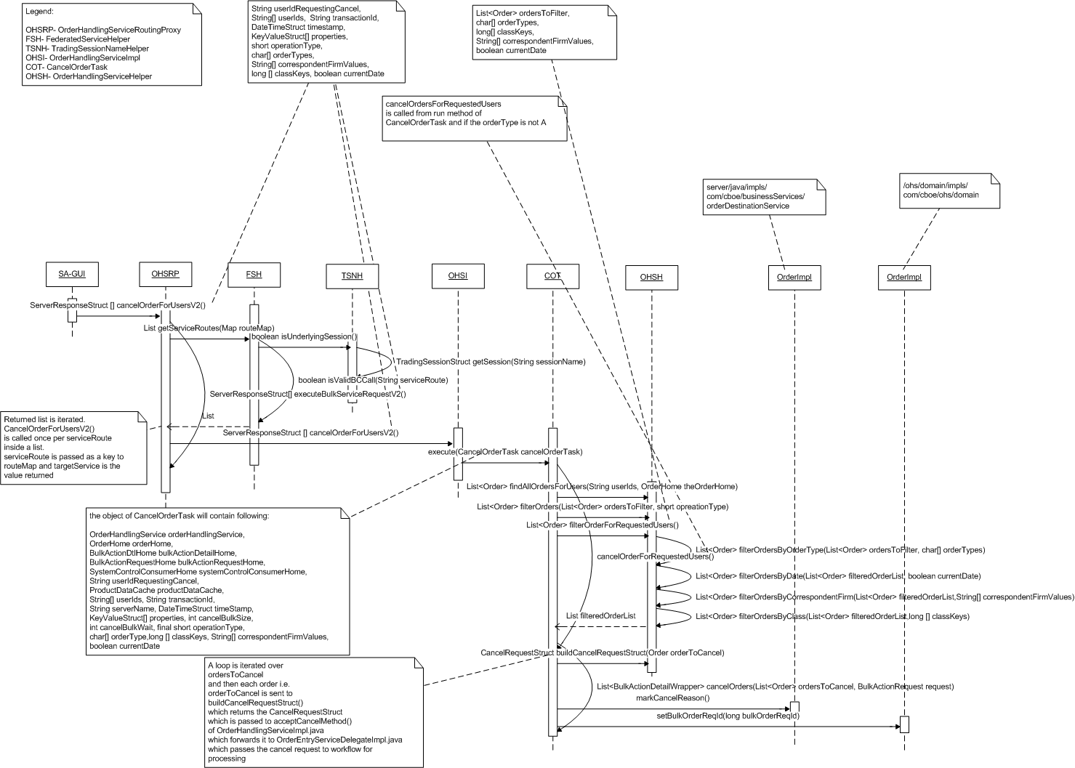
      - SA user executes order cancel request selecting the order types. The call routes through CAS, FE and server.
      - SA GUI calls the new method OrderHandlingServiceRoutingProxy.cancelOrderForUsersV2
      - Method cancelOrderForUsersV2 invokes a private method ServerResponseStruct [] executeBulkServiceRequestV2 () to execute the request.
      - Method executeBulkServiceRequestV2 () calls existing method FederatedServiceHelper. getServiceRoutes (Map routeMap) which validates BC names in routeMap and returns a list of valid BCs i.e. serviceRoutes.
      - For each of the serverRoute, OrderHandlingServiceImpl.cancelOrderForUsersV2 () is invoked. This method returns ServerResponseStruct []. It creates CancelOrderTask object to be passed to execute method of a ThreadPoolExecutor.
      - The CancelOrderTask calls cancelOrderForRequestedUsers()
      - This method calls existing List<Order> findAllOrdersForUsers (String [] userIds, OrderHome theOrderHome) on OrderHandlingServiceHelper which a list of all for the given set of users.
      - After obtaining the list of all orders the method OrderHandlingServiceHelper.filterOrdersForRequestedUsers (List<Order> ordersToFilter, char [] orderTypes, OrderIdStruct correspondentFirmValue, int [] classKeys, boolean currentDate) that filters the list of orders is invoked and only the orders to be cancelled remain in list.
      - The same is passed to the filterOrders to further filter the list by operationType. (Existing implementation)
      - This list is passed to an existing private method List<BulkActionDetailWrapper> cancelOrders (List<Order> ordersToCancel, BulkActionRequest request).
      - Here, acceptCancel method of OrderHandlingServiceImpl is invoked. This method delegates the call to OrderEntryServiceDelegateImpl and subsequently to the workflow.

Cancel Order Flow on given BC’s (Diag. 2)

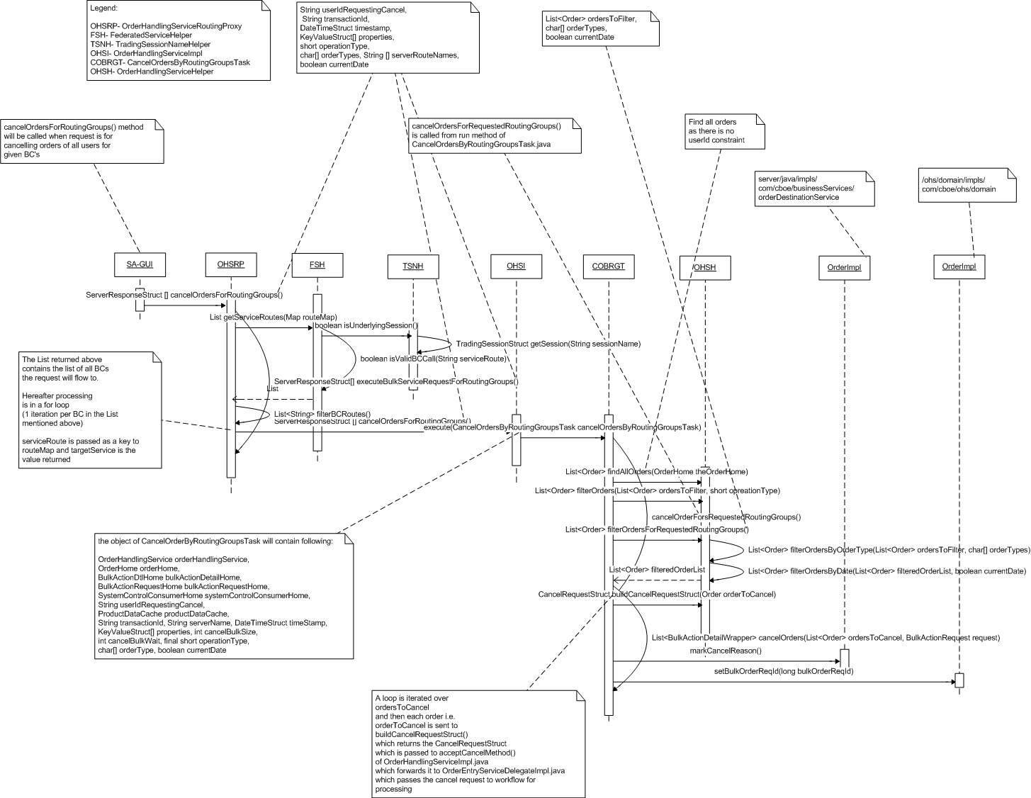

      - SA user executes order cancel request selecting the BC’s with or without constraints (constraints include orderType and date). The call routes through CAS, FE and server.
      - SA GUI calls the new method OrderHandlingServiceRoutingProxy.cancelOrdersForRoutingGroups()
      - Method cancelOrdersForRoutingGroups invokes a private method ServerResponseStruct [] executeBulkServiceRequestForRoutingGroups () to execute the request.
      - Method executeBulkServiceRequestForRoutingGroups () calls existing method FederatedServiceHelper. getServiceRoutes (Map routeMap) which validates BC names in routeMap by executing validation methods in FederatedServiceHelper and TradingSessionNameHelper and returns a list of valid BCs i.e. serviceRoutes.
      - A new private method List <String> filterBCRoutes (serverRouteNames, serviceRoutes) is called to filter only the serverRouteNames specified by the user. Further processing happens only on this list of BCs.
      - For each of the serverRoute, OrderHandlingServiceImpl. cancelOrdersForRoutingGroups () is invoked. This method returns ServerResponseStruct []. It creates CancelOrdersByRoutingGroupsTask object to be passed to execute method of a ThreadPoolExecutor.
      - The CancelOrdersByRoutingGroupsTask calls new method cancelOrdersForRequestedRoutingGroups ()
      - This method calls new method List<Order> findAllOrders (OrderHome theOrderHome) on OrderHandlingServiceHelper. This method returns a list of all orders.
      - After obtaining the list of all orders the method OrderHandlingServiceHelper.filterOrdersForRequestedRoutingGroups (List<Order> ordersToFilter, char [] orderTypes, boolean currentDate) that filters the list of orders is invoked and only the orders to be cancelled remain in list.
      - The same is passed to the existing method filterOrders() to further filter the list by operationType. (Existing implementation)
      - The above filtered list is passed to an existing private method List<BulkActionDetailWrapper> cancelOrders (List<Order> ordersToCancel, BulkActionRequest request).
      - Method cancelOrders() invokes acceptCancel method of OrderHandlingServiceImpl. This method delegates the call to OrderEntryServiceDelegateImpl and call is given to the workflow.

Design for findAllOrders () method (Diag. 3)
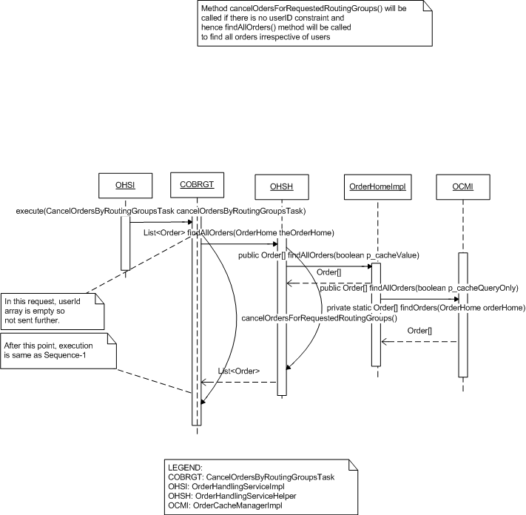

Cancel orders based on the information provided in a spreadsheet. (Diagram 3)

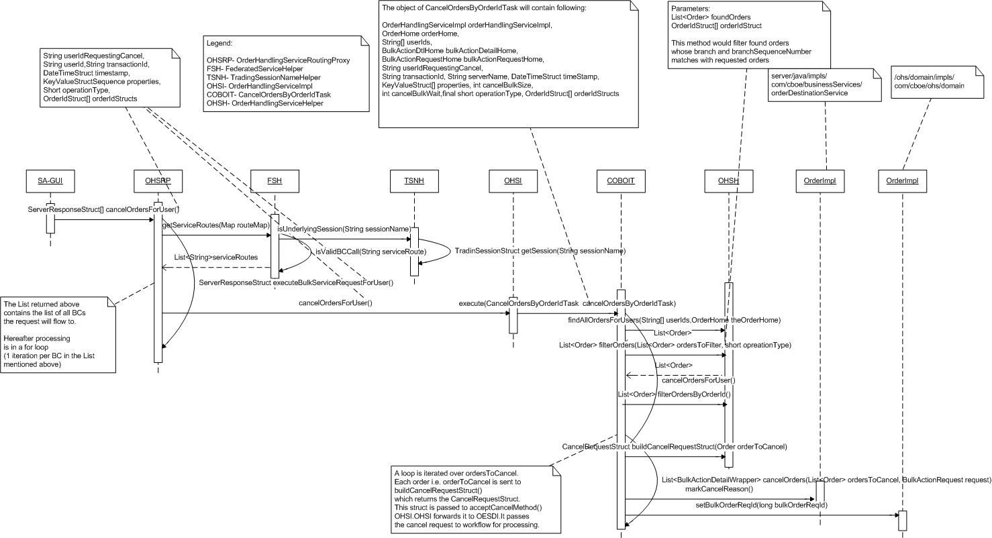

- SA user executes order cancel request by uploading the spreadsheet and sending for cancel. SA- GUI parses that file and send the cancel request for users with sequence of OrderIdStruct.
- SA GUI calls the new method OrderHandlingServiceRoutingProxy.cancelOrdersForUser()
- Method cancelOrdersForUser () invokes a private method ServerResponseStruct [] executeBulkServiceRequestForUser to execute the request.
- Method executeBulkServiceRequestForUser ( ) calls existing method FederatedServiceHelper. getServiceRoutes (Map routeMap) which validates BC names in routeMap by executing validation methods in FederatedServiceHelper and TradingSessionNameHelper and returns a list of valid BCs i.e. serviceRoutes.
- For each of the serverRoute, OrderHandlingServiceImpl.CancelOrdersForUser () is invoked. This method returns ServerResponseStruct []. It creates CancelOrdersByOrderIdTask (new class) object to be passed to execute method of a ThreadPoolExecutor.
- The CancelOrdersByOrderIdTask calls new method cancelOrdersForUser()
- This method calls new method existing List<Order> findAllOrdersForUsers (String [] userIds, OrderHome theOrderHome) on OrderHandlingServiceHelper. This method returns a list of all orders.
- After obtaining the list of all orders the method OrderHandlingServiceHelper.filterOrdersForUser (List<Order> ordersToFilter, OrderIdStruct[] orderIdStructs) that filters the list of orders is invoked and only the orders to be cancelled remain in list.
- The same is passed to the existing method filterOrders () to further filter the list by operationType. (Existing implementation)
- The above filtered list is passed to an existing private method List<BulkActionDetailWrapper> cancelOrders (List<Order> ordersToCancel, BulkActionRequest request).
- Method cancelOrders() invokes acceptCancel method of OrderHandlingServiceImpl. This method delegates the call to OrderEntryServiceDelegateImpl and call is given to the workflow.

- IDL Changes

OrderHandlingService.idl
Location – server/idl/OrderHandlingService.idl
Add a NEW method as follows:
Method trigerred if the request is for cancelling orders on all BC’s for given set of users (The request may have constraints relating to orderType, correspondent Firm, class and date))

util::ServerResponseStructSequence cancelOrderForUsersV2 (
in string userIdRequestingCancel,
in cmiUtil::StringSequence userIds,
in string transactionId,
in cmiUtil::DateTimeStruct timestamp,
in cmiUtil::KeyValueStructSequence properties,
in short operationType,
in cmiOrder::OrderTypeSequence orderTypes,
in cmiUtil::StringSequence correspondentFirmValues,
in cmiProduct::ClassKeySequence classKeys,
in boolean currentDate)
raises(
exceptions::DataValidationException,
exceptions::CommunicationException,
exceptions::SystemException,
exceptions::AuthorizationException
);

Method trigerred if request is for cancelling orders of all users on given BC’s (This request may also have constraints relating to orderType and date)

util::ServerResponseStructSequence cancelOrdersForRoutingGroups (
in string userIdRequestingCancel,
in string transactionId,
in cmiUtil::DateTimeStruct timestamp,
in cmiUtil::KeyValueStructSequence properties,
in short operationType,
in cmiOrder::OrderTypeSequence orderTypes,
in cmiUtil::StringSequence serverRouteNames,
in boolean currentDate)
raises(
exceptions::DataValidationException,
exceptions::CommunicationException,
exceptions::SystemException,
exceptions::AuthorizationException
);

The method below is invoked for canceling orders based on the information given in a spreadsheet.

util::ServerResponseStructSequence cancelOrdersForUser (
in string userIdRequestingCancel,
in string userId,
in string transactionId,
in cmiUtil::DateTimeStruct timestamp,
in cmiUtil::KeyValueStructSequence properties,
in short operationType,
in cmiOrder::OrderIdStructSequence orderIdStructs)
raises(
exceptions::DataValidationException,
exceptions::CommunicationException,
exceptions::SystemException,
exceptions::AuthorizationException
);

cmiOrder.idl
Location – cmi/idl/cmiOrder.idl
Add a NEW typedef character and a NEW sequence as follows:
typedef char OrderType;
typedef sequence <cmiOrder::OrderType> OrderTypeSequence;

3. Interfaces and Classes
Interfaces:

- com.cboe.ohs.domain.interfaces.OrderHome.java
A NEW method will be added to this interface.
  - public Order[] findAllOrders(boolean p_CacheQuery)
- The implementation is in place in existing class OrderHomeImpl that implements OrderHome but the same is not present in the OrderHome.
Classes:

- com.cboe.proxy.businessServices.OrderHandlingServiceRoutingProxy.java
Following NEW methods will be added to this class.
  - public ServerResponseStruct[] cancelOrderForUsersV2(String userIdRequestingCancel, String[] userIds, String transactionId, DateTimeStruct timestamp,KeyValueStruct[] properties, short operationType, char[] orderTypes, String[] correspondentFirmValues, int[] classKeys, boolean currentDate) throws DataValidationException, CommunicationException, SystemException, AuthorizationException
- Delegates the request to executeBulkServiceRequestV2 () with all its parameters.

  - private ServerResponseStruct[] executeBulkServiceRequestV2 (final String userIdRequestingCancel, final String[] userIds, final String transactionId, final DateTimeStruct timestamp, final KeyValueStruct[] properties, final short operationType, final String requestType, final char[] orderTypes , final String[] correspondentFirmValues, final int[] classKeys, final boolean currentDate)
throws SystemException, CommunicationException, DataValidationException,AuthorizationException
- This method gives a callsFederatedServiceHelper.getServiceRoutes (Map routeMap). A list containing all valid BC names is returned.
- If the request is for particular classes then a call is given to a new private method getBCRoutesForClasses () which returns BCs corresponding to classKeys requested.
- After the list is obtained a call is given to cancelOrderForUsersV2 method of OrderHandlingServiceImpl for each serviceRoute.
- In case of any exception in the processing, a method ServerResponseStruct [] getServerResponseStruct () is called. Parameters String serverId, short errorCode, String description are passed.

  - private List<String> getBCRoutesForClasses(int[] classKeys, List<String> serviceRoutes) throws DataValidationException
- Iterate over array of classKeys and for each iteration call method getRouteNamesByClass of ProductRoutingServiceImpl.java which returns HashSet of routeName for a given classKey.
- Get the value of routename from HashSet and add it to String array and pass it to new private method filterBCRoutes() which returns a list of routeNames in sessionName:serverRouteNames
- Obtained list is returned.

  - private List <String> filterBCRoutes (final List<String> serviceRoutes, final String[] serverRouteNames)
- This method loops for the serverRouteNames elements to get the list of valid BCs.

  - public ServerResponseStruct[] cancelOrdersForRoutingGroups (String userIdRequestingCancel, String transactionId, DateTimeStruct timestamp, KeyValueStruct[] properties, short operationType, char[] orderTypes, String[] serverRouteNames, boolean currentDate) throws SystemException, CommunicationException, DataValidationException, AuthorizationException
- This method delegates the call to new method executeBulkServiceRequestForRoutingGroups() method

  - private ServerResponseStruct[] executeBulkServiceRequestForRoutingGroups(final String userIdRequestingCancel ,final String transactionId, final DateTimeStruct timestamp, final KeyValueStruct[] properties, final short operationType, final String requestType, final char[] orderTypes, final String[] serverRouteNames,
final boolean currentDate) throws SystemException, CommunicationException, DataValidationException,AuthorizationException
- This method gives a call to an existing method FederatedServiceHelper.getServiceRoutes (Map routeMap). A list containing all valid BC names is returned.
- This list is passed to new private method List <String> filterBCRoutes (List serviceRoutes, String [] serverRouteNames) which filters the serviceRoutes to contain only the user requested serverRouteNames. Further processing happens only on these BCs.
- After the list is obtained a call is given to cancelOrdersForRoutingGroups () method of OrderHandlingServiceImpl for each serviceRoute
- In case of any exception in the processing, an existing method ServerResponseStruct [] getServerResponseStruct () is called. Parameters String serverId, short errorCode, String description are passed.

  - public ServerResponseStruct[] cancelOrdersForUser(String userIdRequestingCancel,String userId, String transactionId, DateTimeStruct timeStamp, KeyValueStruct[] properties,short operationType, OrderIdStruct[] orderIdStructs) throws SystemException, CommunicationException, DataValidationException,AuthorizationException
- This method delegates the call to executeBulkServiceRequestForUser () method

  - private ServerResponseStruct[] executeBulkServiceRequestForUser(final String userIdRequestingCancel ,String userId,final String transactionId, final DateTimeStruct timeStamp, final KeyValueStruct[] properties, final short operationType, final String requestType,OrderIdStruct[] orderIdStructs) throws SystemException, CommunicationException, DataValidationException, AuthorizationException
- This method gives a calls FederatedServiceHelper.getServiceRoutes (Map routeMap). A list containing all valid BC names is returned.
- After the list is obtained a call is given to cancelOrdersForUser() method of OrderHandlingServiceImpl for each serviceRoute.
- In case of any exception in the processing, a method ServerResponseStruct [] getServerResponseStruct () is called. Parameters String serverId, short errorCode, String description are passed.

- com.cboe.ohs.receivers.ohs.OrderHandlingServiceImpl.java
TWO NEW methods will be added to this class.
  - public ServerResponseStruct[] cancelOrderForUsersV2(String userIdRequestingCancel, String[] userIds, String transactionId, DateTimeStruct timestamp,KeyValueStruct[] properties, short operationType, char[] orderTypes, String[] correspondentFirmValues, int[] classKeys, boolean currentDate) throws DataValidationException, CommunicationException, SystemException, AuthorizationException
- This method firstly validates the inputs vis-à-vis users, ordertype, correspondentFirm and classKeys and invokes the CancelOrderTask Thread.

  - public ServerResponseStruct[] cancelOrdersForRoutingGroups (String userIdRequestingCancel, String transactionId, DateTimeStruct timestamp, KeyValueStruct[] properties, short operationType, char[] orderTypes, String[] serverRouteNames, boolean currentDate) throws SystemException, CommunicationException, DataValidationException, AuthorizationException
- This method firstly validates the input parameters vis-à-vis userId requesting cancel, orderType and call the CancelOrdersByRoutingGroupsTask (new class).

  - public ServerResponseStruct[] cancelOrdersForUser(String userIdRequestingCancel,String userId, String transactionId, DateTimeStruct timestamp, KeyValueStruct[] properties,short operationType, OrderIdStruct[] orderIdStructs) throws SystemException, CommunicationException, DataValidationException,AuthorizationException
- This method firstly validates the inputs vis-à-vis user and invokes the CancelOrdersByOrderIdTask (new class) Thread

- com.cboe.server.util.FederatedServiceHelper.java
Two NEW methods will be added as follows:
  - public static void validateOrderTypes(final char[] orderTypes) throws DataValidationException
- In this method orderType array is iterated and each order type is checked for valid values given in TimesInForce interface.
  - public static void validateCorrespondentFirm(String[] corrrespondentFirmValues) throws DataValidationException
- Check if the array of correspondentFirmValues is null and if found null then throw DataValidatonException
  - public static void validateClassKeys(int[] classKeys) throws DataValidationException
- Check if the array of classKeys is null and if found null then throw DataValidatonException

- com.cboe.ohs.receivers.ohs.CancelOrderTask.java
Constructor will be overloaded with orderType character array, correspondentFirmValue, long classKey and boolean currentDate.
  - public CancelOrderTask(OrderHandlingService orderHandlingService,
OrderHome orderHome, BulkActionDtlHome bulkActionDetailHome,
BulkActionRequestHome bulkActionRequestHome,
SystemControlConsumerHome systemControlConsumerHome,
String userIdRequestingCancel, ProductDataCache productDataCache,
String[] userIds, String transactionId, String serverName,DateTimeStruct timeStamp,
KeyValueStruct[] properties,int cancelBulkSize, int cancelBulkWait, final short operationType, final char[] orderTypes, String[] correspondentFirmValues, int[] classKeys, boolean currentDate)

Method run will be modified with these changes:
  - public void run()
- Inside run method of CancelOrderTask a switch is added. Switch checks that whether orderType or classKeys array or correspondentFirmValues array is not null and calls the new method cancelOrdersForRequestedUsers()
- If the above condition is not satisfied then the existing method cancelOrderForUsers() is called

Below method will be added to this class.

A NEW method will be added as shown below:

  - private void cancelOrderForRequestedUsers()
- In this method an object of BulkActionRequest is created by calling existing method FederatedServiceHelper.persistBulkActionRequest (). This object contains information like timeStamp, userIdRequestingCancel, operationType, orderType, transactionId, serverName and properties object. This method saves this information in database table bulk_action_request.
- After this data is persisted, an existing method List<Order> findAllOrdersForUsers () of OrderHandlingServiceHelper.java is called. The parameters passed are userId array and OrderHome theOrderHome to fetch the complete order list for the given users.
- On this order list a filter is applied by calling an existing method filterOrders ().
- The list obtained from above filter would have ORDERS and IORDERS both.
- Call new method filterOrdersForRequestedUsers (List<Order> ordersToFilter, char [] orderTypes, String [] correspondentFirmValues, long [] classKeys, boolean currentDate) to filter orders according to the request made. It accepts the order list returned by above method and returns the filtered list for further processing. This list can contain only ORDERS for requested users.
- Next, an existing private method cancelOrders () is called. This method returns list of BulkActionDetailWrapper objects which are persisted later with a call to persistBulkActionDtl method of OrderHandlingServiceHelper.
- The information is published back to GUI by calling method prepareFederatedResponseSummaryStruct() FederatedServiceHelper.java

- com.cboe.ohs.receivers.ohs.OrderHandlingServiceHelper.java
Below mentioned NEW methods will be added to this class.
  - public static List<Order> findAllOrders (OrderHome theOrderHome)
- This method calls a private method findOrders (OrderHome).
  - private static List<Order> findOrders(OrderHome theOrderHome)
- This method calls a method public Order [] findAllOrders (boolean p_cacheQueryOnly) on OrderHomeImpl. This method returns a list of orders on this BC.
  - public static List<Order> filterOrdersForRequestedRoutingGroups(List<Order> ordersToFilter, char[] orderTypes, boolean currentDate)
- Check if the ordersTofilter list is not null and then create a new list filteredOrderList.
- Call new method filterOrdersByOrderType (List<Order> ordersToFilter, char [] orderTypes). Filters the orders based on the orderType.
- Call new method filterOrdersByDate () and pass filteredOrderList and boolean currentDate as a parameter. Filters the orders based on date.
- Finally return the filteredOrderList.

  - public static List<Order> filterOrdersForRequestedUsers(List<Order> ordersToFilter, char[] orderTypes, long[] classKeys, String[] correspondentFirmValues, boolean currentDate)
- Check if the ordersTofilter list is not null and then create a new list filteredOrderList.
- Call new method filterOrdersByOrderType (List<Order> ordersToFilter, char [] orderTypes). Filters the order by orderType
- Call new method filterOrdersByDate() and pass filteredOrderList and boolean currentDate as a parameter. Filters the orders by date.
- Call new method filterOrderByCorrespondentFirm () and pass filterOrderByCorrespondentFirm and CorrespondentFirm to it. Filters the orders by correpondent firm.
- Call new method filterOrderByClass () and pass long [] classKeys and filteredOrderList as the parameter. Returns the orders for the given list of classes.
- Finally return the filteredOrderList.

  - public static List<Order> filterOrdersByOrderType(List<Order> filteredOrderList, char[] orderTypes)
- Check if the ordersTofilter list is not null and then create a new list filteredOrderList.
- Loop over the ordersToFilter.
- In each iteration, an order is checked for the user specified order type (DAY, GTC or GTD) and stored in a list.
- Finally a filtered list is returned.

  - public static List<Order> filterOrdersByDate (List<Order> filteredOrderList, boolean currentDate)
- In this method the boolean value of currentDate is checked if it is true or false.
- If true then it means only todays order are to be cancelled and false means orders of all dates are to be cancelled.
- If false the whole list is returned as it is.
- Else a loop is iterated over ordersToFilter and for each order its ORDERDATE is found.
- In if condition the value of ORDERDATE is compared with currentDate and checked whether it is of current date.
- If date of order is current date then it is added to a list.
- And finally a list filtered on date is returned.

  - public static List<Order> filterOrderByCorrespondentFirm(List<Order> filteredOrderList, String[] correspondentFirmValue)
- Check if the ordersTofilter list is not empty and then create a new list filteredOrderList.
- Then loop is iterated over the ordersToFilter.
- In each iteration the value of the correspondentFirm of an order is compared with that of correspondentFirmValue as requested.
- If both are same then the order is added to the list.
- Finally the filtered list by correspondentFirm is returned.

  - public static List<Order> filterOrderByClass(List<Order> filteredOrderList, long[] classKeys)
- Check if the ordersTofilter list is not empty and then create a new list filteredOrderList.
- In this method a loop is iterated first over classKeys and then over ordersToFilter.
- In each iteration the orders classKey is compared with that of the requested classKey.
- If both are same then that order is added to the list.
- Finally the list filtered by classKey is returned.
  - public static List<Order> filterOrdersByOrderId (List<Order> foundOrders, OrderIdStruct[] orderIdStruct)
- Check if the ordersTofilter list is not empty, null and then create a new list filteredOrderList.
- Iterate over foundOrders List and then on OrderIdStruct array and for each iteration compare the branch and branchSequenceNumber of each order with that of requested order
- If both are matched then add them to list.
- Finally return the filtered list

CLASSES:

Add a new class com.cboe.ohs.receivers.ohs.CancelOrdersByRoutingGroupsTask .java
  - public Class CancelOrdersByRoutingGroupsTask implements BulkTask
- Since the CancelOrderTask is more users centric we are defining a new class here "CancelOrdersByRoutingGroupsTask ". This would have similar implementation as CancelOrderTask today with new menthods to accomodate the new parameters (hence filters) we need apply ... viz. OrderType, Date.

Constructor:
  - public CancelOrdersByRoutingGroupsTask(OrderHandlingService orderHandlingService, OrderHome orderHome, BulkActionDtlHome bulkActionDetailHome, BulkActionRequestHome bulkActionRequestHome,
SystemControlConsumerHome systemControlConsumerHome,
String userIdRequestingCancel, ProductDataCache productDataCache,
String transactionId, String serverName, DateTimeStruct timeStamp,
KeyValueStruct [] properties, int cancelBulkSize,
int cancelBulkWait, final short operationType, final char [] orderTypes,
boolean currentDate)

Add the following methods:
  - public void run()
- call method cancelOrdersForRequestedRoutingGroups()
  - private void cancelOrdersForRequestedRoutingGroups ()
- Logic to persist the data to bulk_action_request similar to what we have in CancelOrderTask.
- After this data is persisted, a method List findAllOrders () of OrderHandlingServiceHelper.java is called. The parameters passed are OrderHome theOrderHome to fetch the complete order list.
- On this list a filter is applied by calling filterOrders (). Parameters to it are List<Order> foundOrders, short operationType. This filters order by the specified operationType. The list contains either ORDERS or IORDERS.
- Call method filterOrdersForRequestedRoutingGroups (List<Order> ordersTocancel, char [] orderTypes, boolean currentDate) to filter orders according to the request made. It accepts the order list returned by above method and returns the filtered list for further processing. This list would contain only ORDERS.
- Next, a private method cancelOrders () is called. This method returns list of BulkActionDetailWrapper objects which are persisted later with a call to persistBulkActionDtl method of OrderHandlingServiceHelper.
- The information is published back to GUI by calling method prepareFederatedResponseSummaryStruct() FederatedServiceHelper.java

  - private List<BulkActionDetailWrapper> cancelOrders(List<Order> ordersToCancel,BulkActionRequest request)
- This method would have the same implementation as the private method cancelOrders() in existing class CancelOrderTask.java

Add a new class com.cboe.ohs.receivers.ohs.CancelOrdersByOrderIdTask .java
  - public Class CancelOrdersByOrderIdTask implements BulkTask

Constructor:
  - public CancelOrdersByOrderIdTask(OrderHandlingService orderHandlingService,
OrderHome orderHome, BulkActionDtlHome bulkActionDetailHome,
BulkActionRequestHome bulkActionRequestHome, SystemControlConsumerHome
systemControlConsumerHome, String serverName, String userIdRequestingCancel, ProductDataCache productDataCache, String[] userIds, String transactionId, DateTimeStruct timeStamp, KeyValueStruct[] properties, int cancelBulkSize, int cancelBulkWait, final short operationType,OrderIdStruct[] orderIdStructs)
Add the following methods:
  - public void run()
- call method cancelOrdersForUser()
  - private void cancelOrdersForUser()
- Logic to persist the data to bulk_action_request similar to what we have in CancelOrderTask.
- After this data is persisted, an existing method List<Order> findAllOrdersForUsers () of OrderHandlingServiceHelper.java is called. The parameters passed are OrderHome theOrderHome to fetch the complete order list for given user.
- On this list a filter is applied by calling existing method filterOrders(). Parameters to it are List<Order> foundOrders, short operationType. This filters order by the specified operationType. The list contains either ORDERS or IORDERS.
- Call method filterOrdersForUser (List<Order> foundOrders, OrderIdStruct [] orderIdStructs) to filter orders according to the request made. It accepts the order list returned by above method and returns the filtered list for further processing. This list would contain only ORDERS.
- Next, a private method cancelOrders () is called. This method returns list of BulkActionDetailWrapper objects which are persisted later with a call to persistBulkActionDtl method of OrderHandlingServiceHelper.
- The information is published back to GUI by calling method prepareFederatedResponseSummaryStruct() FederatedServiceHelper.java
  - private List<BulkActionDetailWrapper> cancelOrders(List<Order> ordersToCancel,BulkActionRequest request)
- This method would have the same implementation as the private method cancelOrders() in existing class CancelOrderTask.java

Logging
1. Informative messages will be logged at the beginning and end of each important method.

Exception Handling
All the exceptions will be logged and propagated to the top level (i.e. the SA GUI)

Scripts(2)
None

Database(.5)
None

SetContext(.125)
None

XML/DTD(.5)
None

Homes/Services(2)
- OrderHandlingService
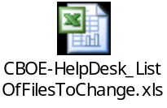

ImplPlan(.5)
None

PerformanceTestingProcedure(1)
None

TestingProcedure(1)
None

OperatorProcedure(.5)
None

Fallback/Failover
None

GUI Design
NA
Queries
- Do we need to add the orderType (or any other constraint details) to the table keeping track of the bulk requests? The existing setup through the FederatedServiceHelper.persistBulkActionRequest inserts a row into the table bulk_action_request importantly maintaining the actionRequest type (IORDER_CANCEL or ORDER_CANCEL). User requesting the cancel, serverName.

- The cancel request for All Orders Types would be sent as:
  - Complete array of orderTypes OR
  - An empty char array?

Answer: For all orders the request would be like {‘G’,’T’,’C’}.

- The cancel request to All BCs would be sent as:
  - The entire list OR
  - An empty String array?

Answer: No such request would actually come.

- BC list will be
  - List of routeName like test5HybridTradeServer1 Or
  - sessionName: routeName like W_MAIN:test5HybridTradeServer1?

Answer: BC list would be like test5HybridTradeServer1 only without session name

- How would the exceptions in a group request (batch process) be handled?
  - Log and proceed.
  - LogThrow exception (stop processing further list)

- What is the significance of the param RoutingParams in the method OHSRP.cancelOrderforUsers? Can this be used to communicate the BC List (See the suggestions section below for approach details with BC List being created from data available in RoutingParams)

Answer: In the new design proposed, routingParam will not be used to store group keys, instead a separate parameter will be passed for that.

- public Order[] findAllOrders(boolean p_cacheQueryOnly) method of OrderCacheManagerImpl takes a boolean parameter that is not used in the method. What is the significance of this boolean parameter? . As per Assumption#4 we will not use this switch and by default pass true as a value.

- There is an existing method findAllOrders (Boolean) inside OrderHomeImpl. It is being called from OrderHandlingServiceHelper. The method is present in OrderHomeImpl but not defined in interface OrderHome! As a result we were getting ‘can not find symbol’ error whenever we were building OHS folder for errors. We have written a method definition in OrderHome to remove the error.

- Can there be a request for cancelling orders pertaining to multiple correspondent firms.
Answer: Yes the parameter correspondent firm would be a String array.

- How would be the Cancel request for ALL condition for correspondent firms sent?
- When we are cancelling orders for given BC’s what all combinations are possible with a BC??
(We have assumed that date and orderTypes are the two constraints which can go with BC’s)
Answer: The combinations possible with BC are orderType and date.

- What will be the default values(i.e. none condition) of the parameters:
- correspondentFirmValue
- classKeys
In the current design we have gone by assuming it can be empty. No assumption explicitly mentioned for this.

- Comments welcome on introducing new class CancelOrdersByRoutingGroupsTask for processing of cancel orders for given BCs.
Response: This is required and accepted

- How to utilize the classKeys in OrderHandlingServiceRoutingProxy.java for cancelling orders pertaining to given classKeys?
Design Approach1: We give call to all the BCs as it happens today (# of calls equals to # of BCs) BCs not catering to a particular class would return once filtering by classKeys is done.

Design Approach2: We find out the BC which caters the particular classKey and send the cancel request only to that BC (other BCs are not bothered for the purpose)

Answer: We should go by Approach 2.

